**DAILY ONLINE ACTIVITIES SUMMARY**

|  |  |  |  |  |  |  |  |  |
| --- | --- | --- | --- | --- | --- | --- | --- | --- |
| **Date:** | **25/06/2020** | | | | | **Name:** | **Lavanya D M** | |
| **Sem & Sec** | **4th & ‘A’** | | | | | **USN:** | **4al18cs041** | |
| **Online Test Summary** | | | | | | | | |
| **Subject** | | **C++ quiz by shurthi ma’am** | | | | | | |
| **Max. Marks** | | **30** | | **Score** | | | **20** | |
| **Certification Course Summary** | | | | | | | | |
| **Course** | **Creating blog** | | | | | | | |
| **Certificate Provider** | | | **Bitdegree** | | **Duration** | | | **1week** |
| **Coding Challenges** | | | | | | | | |
| **Problem Statement:**  1 Write a C Program to reverse the rows in a 2d Array  2) Java program to print Hollow Mirrored Right Triangle Star Pattern | | | | | | | | |
| **Status: Complied** | | | | | | | | |
| **Uploaded the report in Github** | | | | | **yes** | | | |
| **If yes Repository name** | | | | | <https://github.com/lavanyamurthi/lockdown-coding> | | | |
| **Uploaded the report in slack** | | | | | **yes** | | | |

Online Test Details: (Attach the snapshot and briefly write the report for the same)

Today class is conducted on C++ by Shruthi Shetty ma’am in which we learn about the basic concept of C++, and even we had test

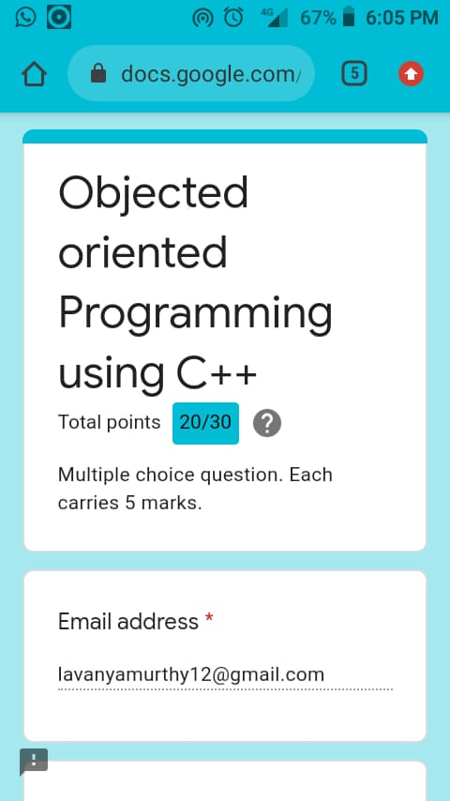

Certification Course Details: (Attach the snapshot and briefly write the report for the same)

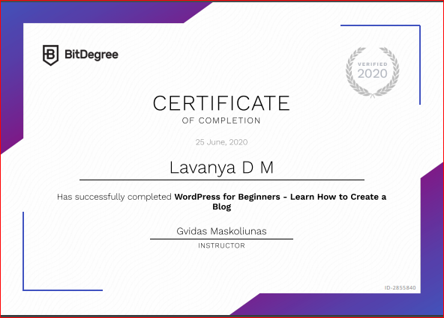

Coding Challenges Details: (Attach the snapshot and briefly write the report for the same)

**Problem 1** : Write a C Program to reverse the rows in a 2d Array

Given a 2D array arr[][] of size M x N integers where M is the number of rows and N is the number of columns. The task is to reverse every row of the given 2D array.

**Example:**

**Input:** arr[][] =  
{ {1, 2, 3},  
{4, 5, 6},  
{7, 8, 9} }  
**Output:**  
3 2 1  
6 5 4  
9 8 7

**Input:** arr[][] =  
{ {1, 2},  
{4, 5},  
{7, 8},  
{9, 10} }  
**Output:**  
2 1  
5 4  
8 7  
10 9

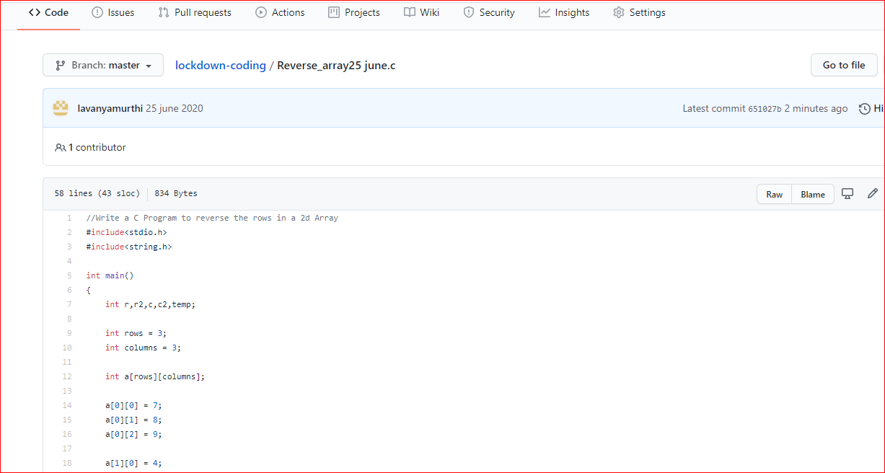

**Problem 2:**  Java program to print Hollow Mirrored Right Triangle Star Pattern

